ENTITY FRAMEWORK

**ENTITY FRAMEWORK**

**SHILPA VAIDYA**

**SGVAIDYAS@GMAIL.COM**

PROJECT CREATION

CREATED FOR VIRTUSA

DATABASE FIRST APPROACH

CREATE

DATABASE

**DESIGNING DATABASE BEFORE CREATING NECESSARY CODE LOGIC FOR THE REST OF THE APPLICATION.**

**Create database**

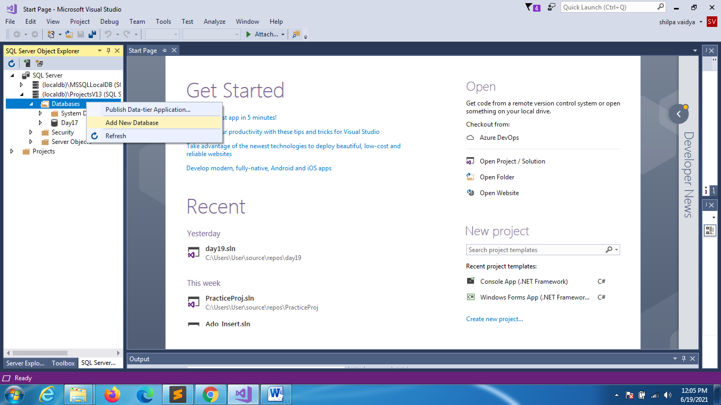

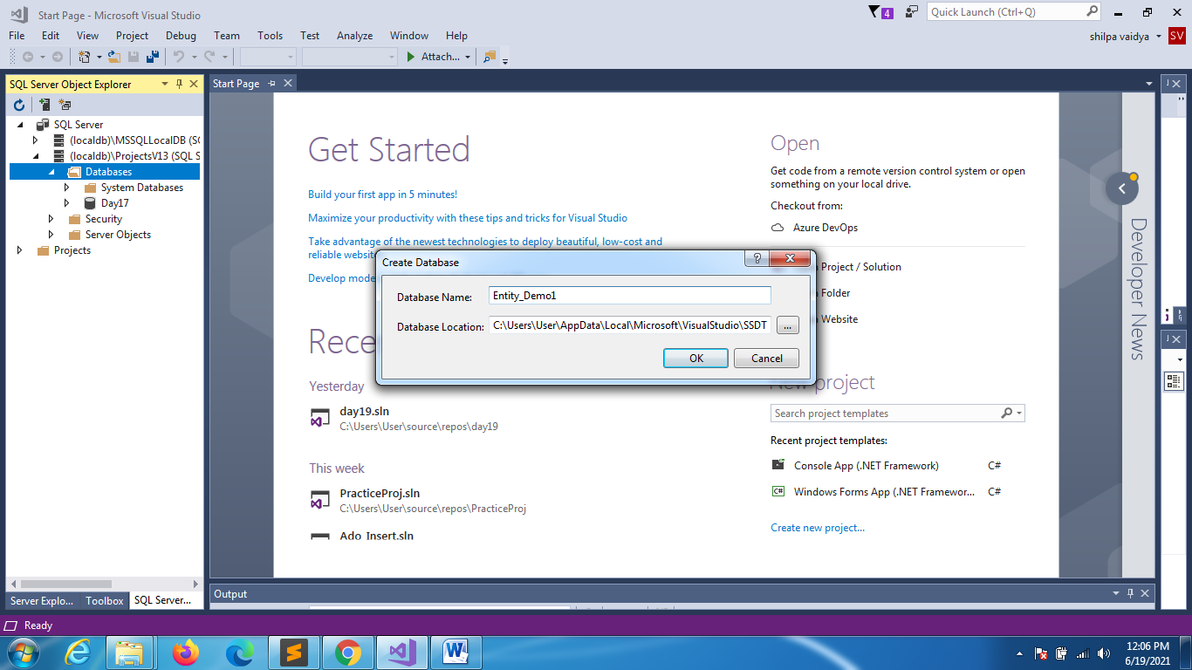

**CREATE TABLE:**

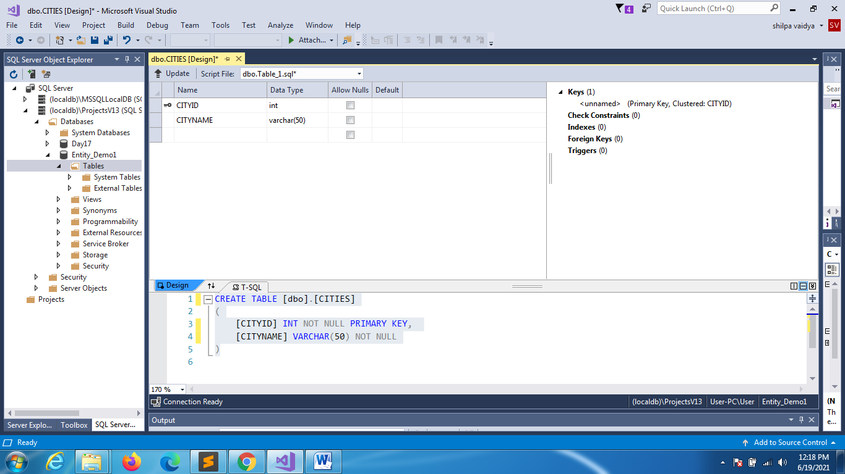

**ONCE YOU CLICK UPDATE:**

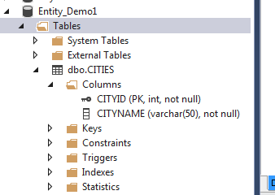

**CREATE CITIES TABLE:**

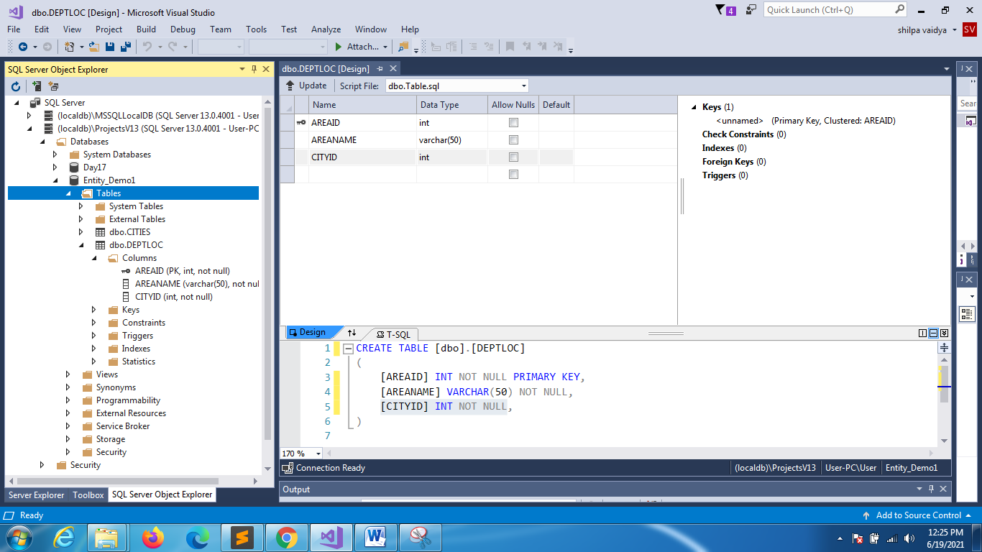

**ADD FOREIGN KEY CONSTRAINT TO DEPT**

ALTER TABLE DEPTLOC

ADD CONSTRAINT FK_CITYID

FOREIGN KEY (CITYID) REFERENCES CITIES(CITYID);

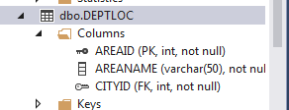

**CREATE PROJECT(consoleapp)**

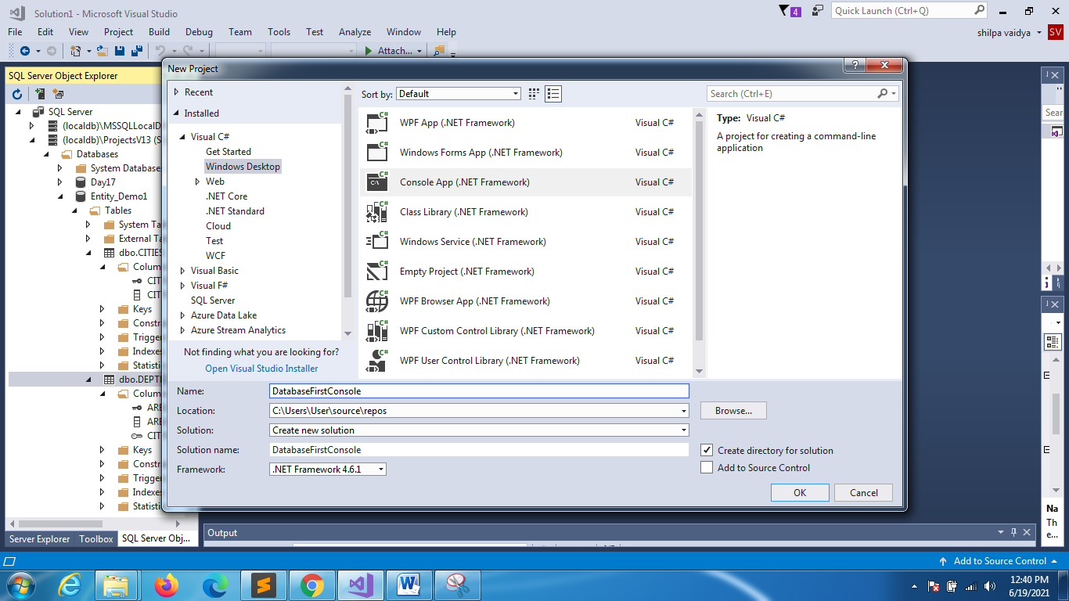

CREATE

CONSOLE APPLICATION

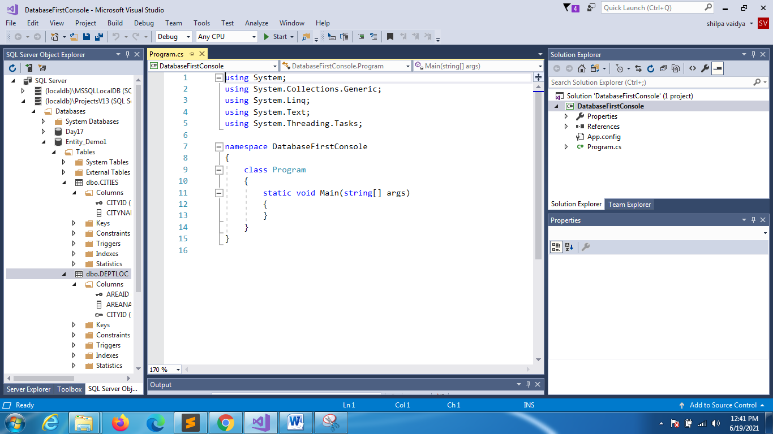

**ADD NEW ITEM**

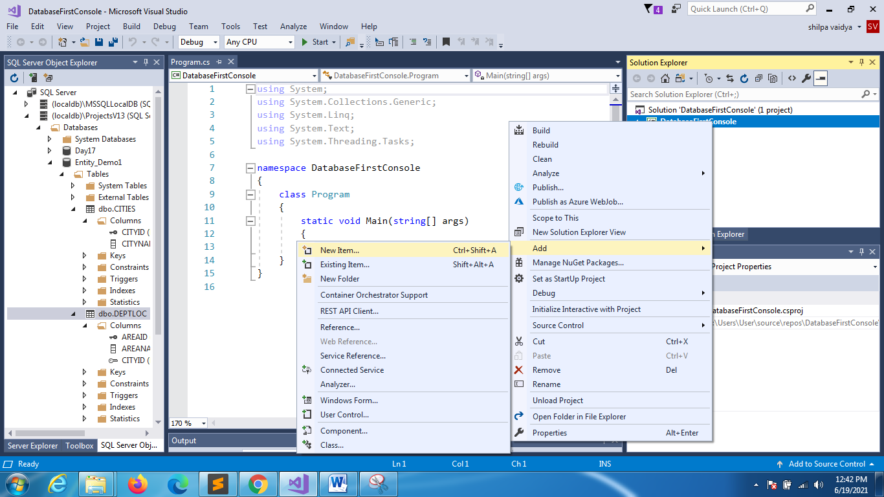

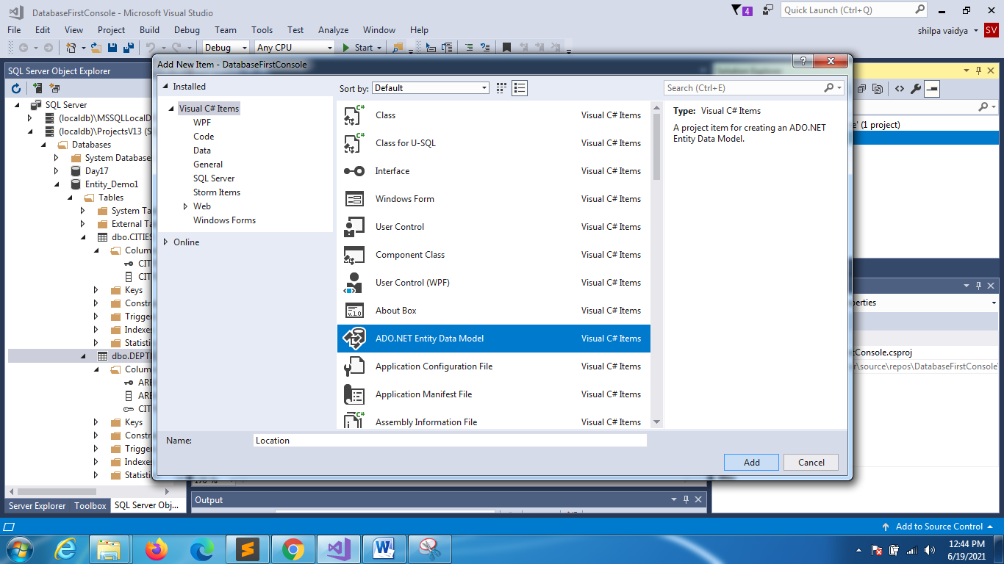

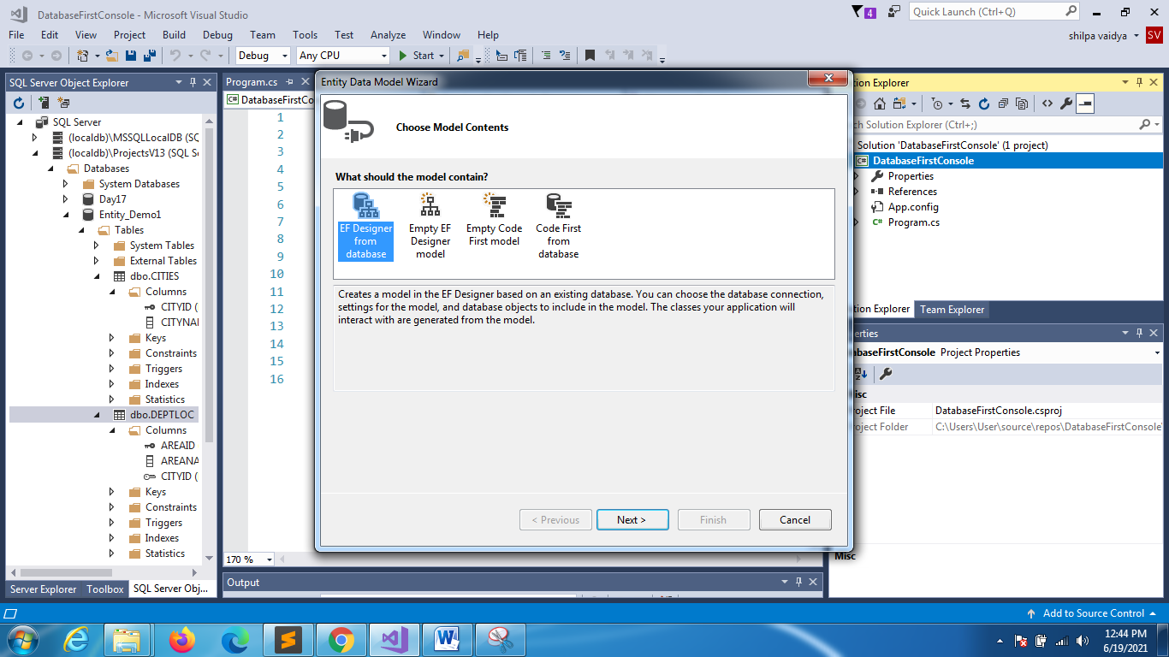

ALREADRY DB EXISTS STILL USED FOR

CODE FIRST APPROACH

IS USED FOR

CODE FI RST APPROACH

IS USED FOR

MODEL FI RST APPROACH

WE CHOOSE THIS CAUSE DATABASE FIRST APPROACH

**CLICK NEW CONNECTION**

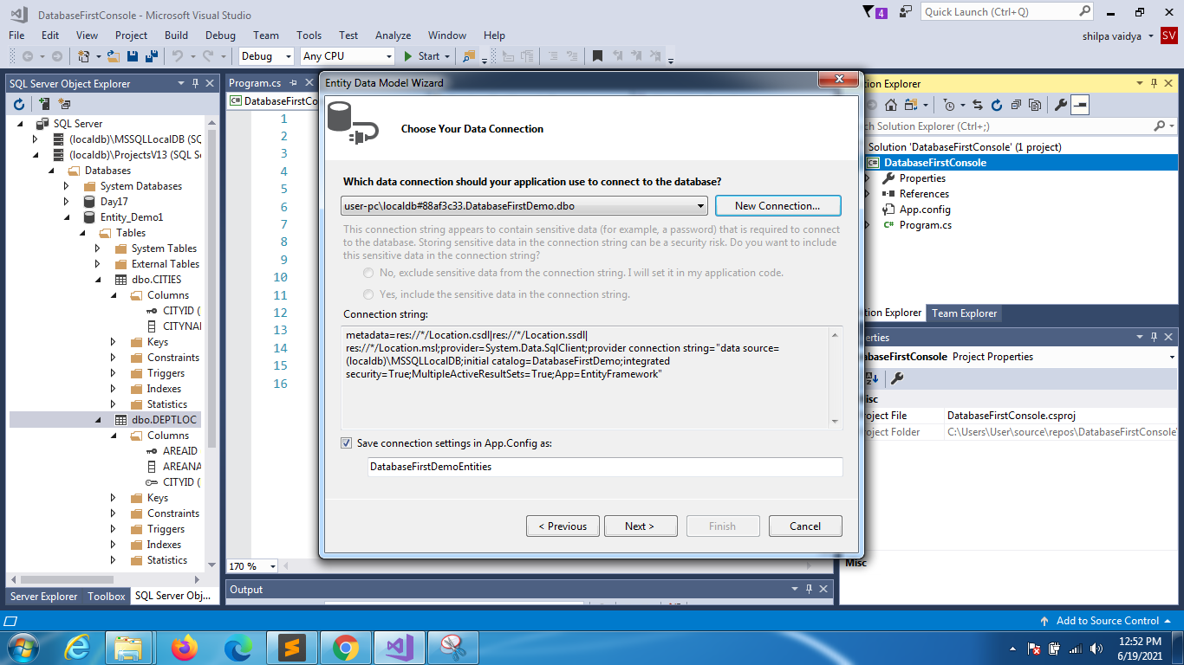

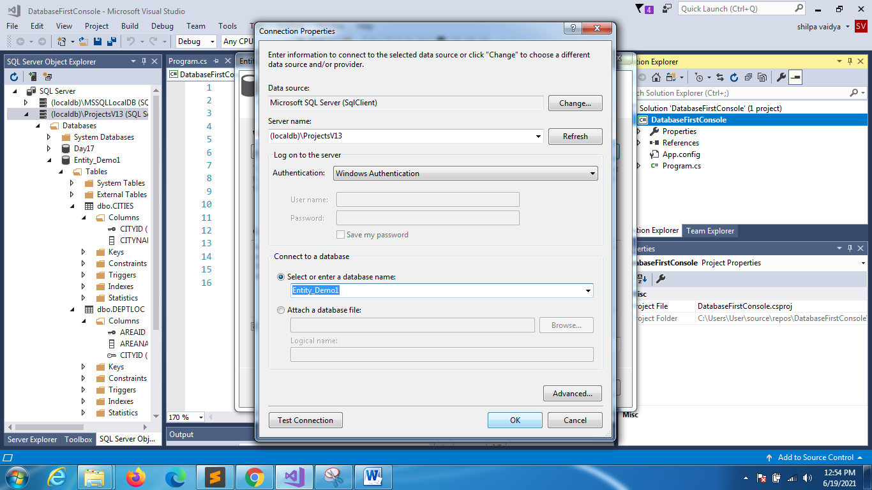

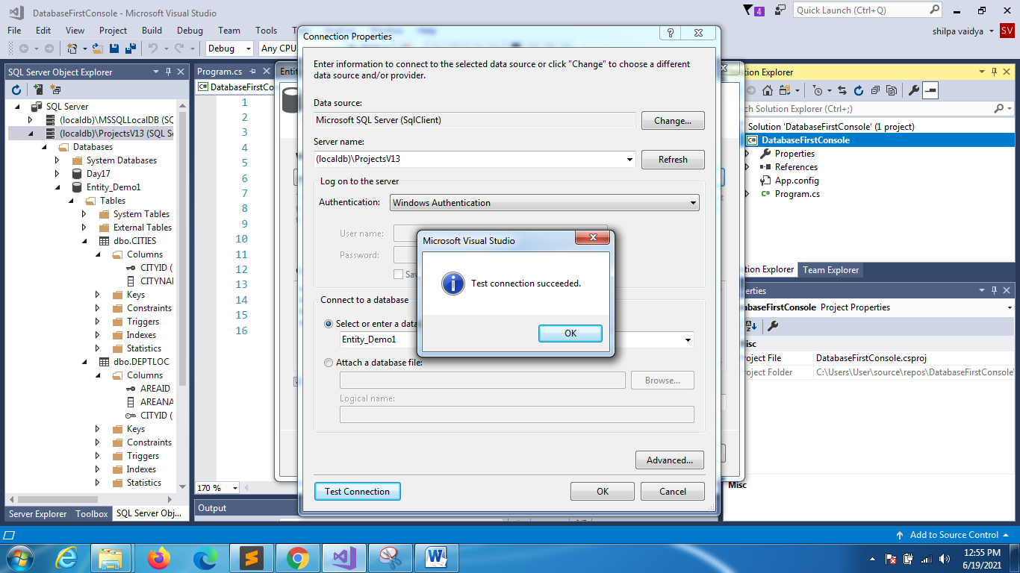

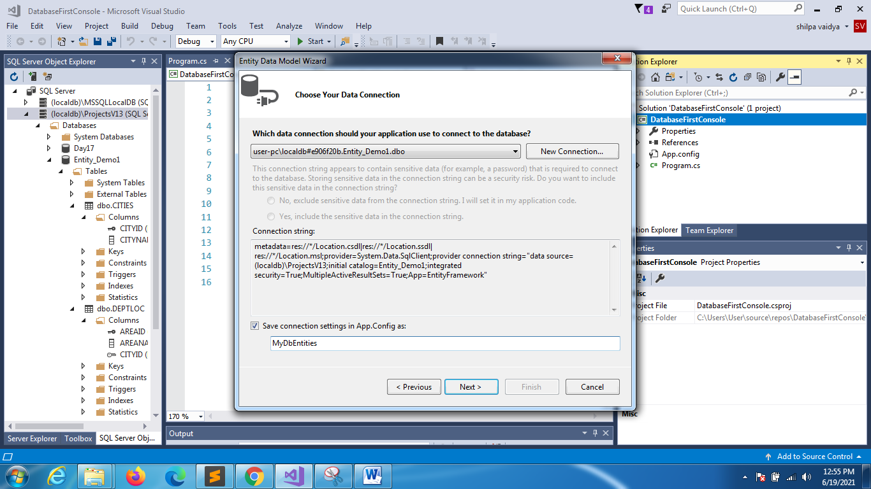

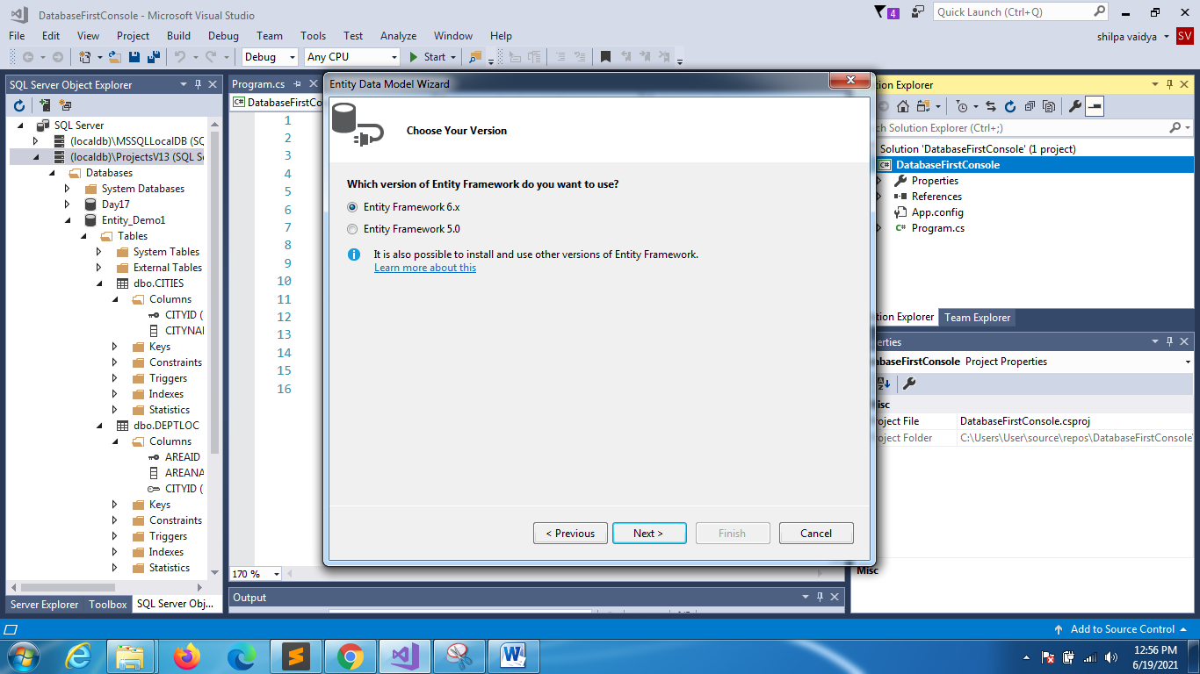

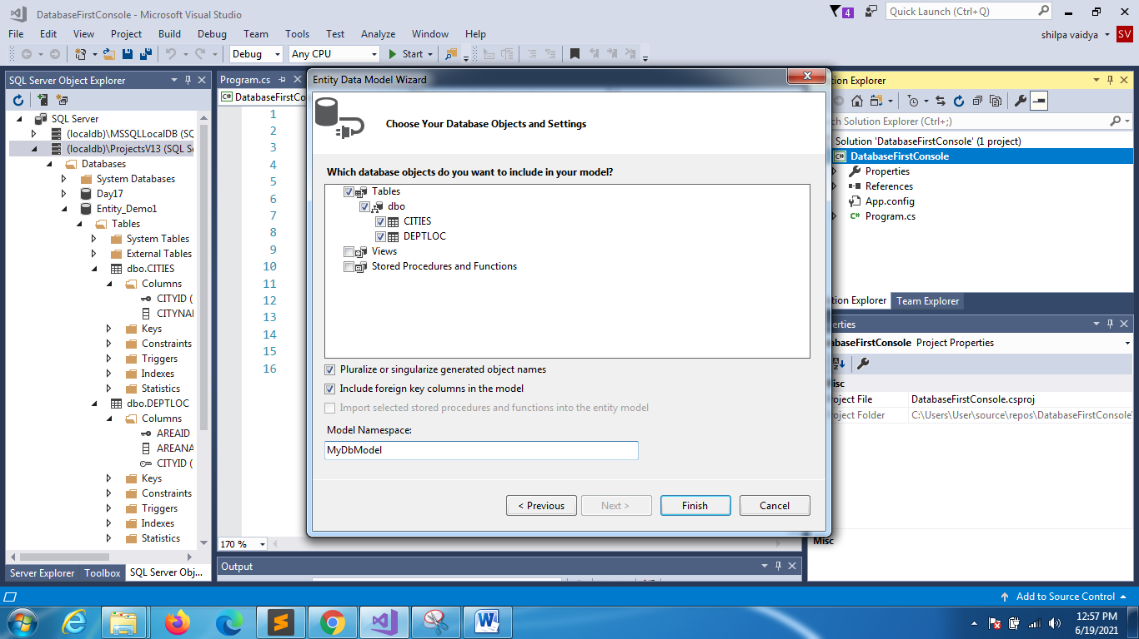

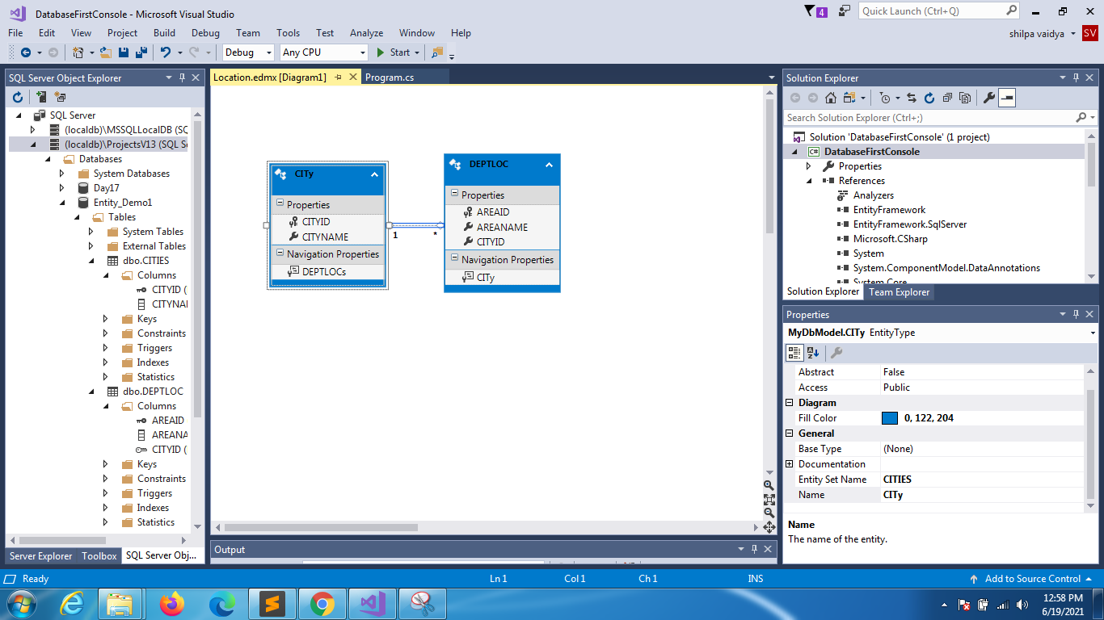

**If you want to see xml structure**

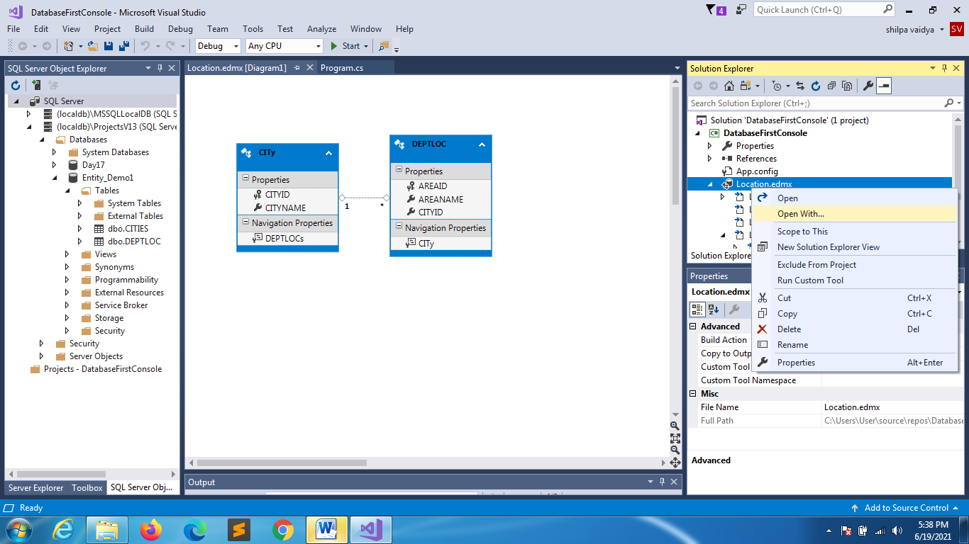

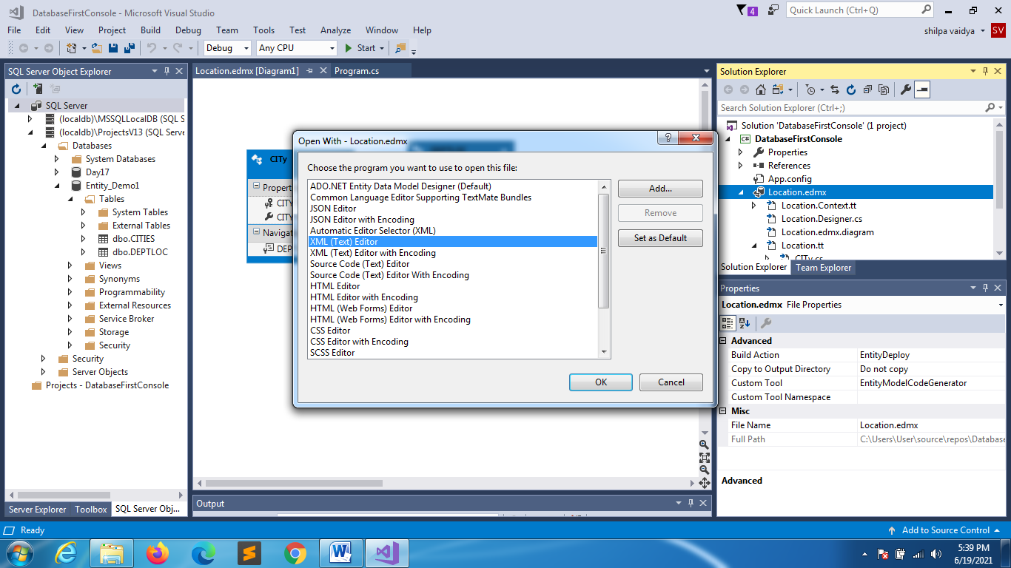

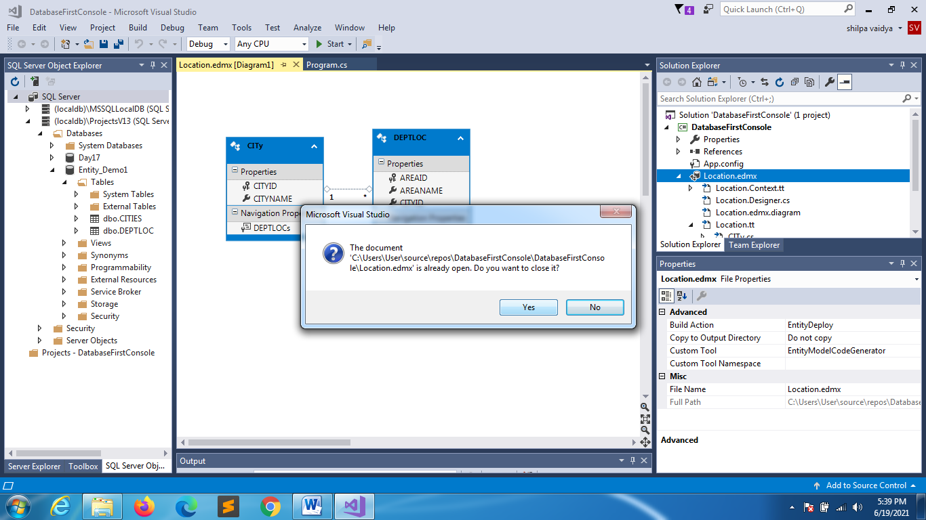

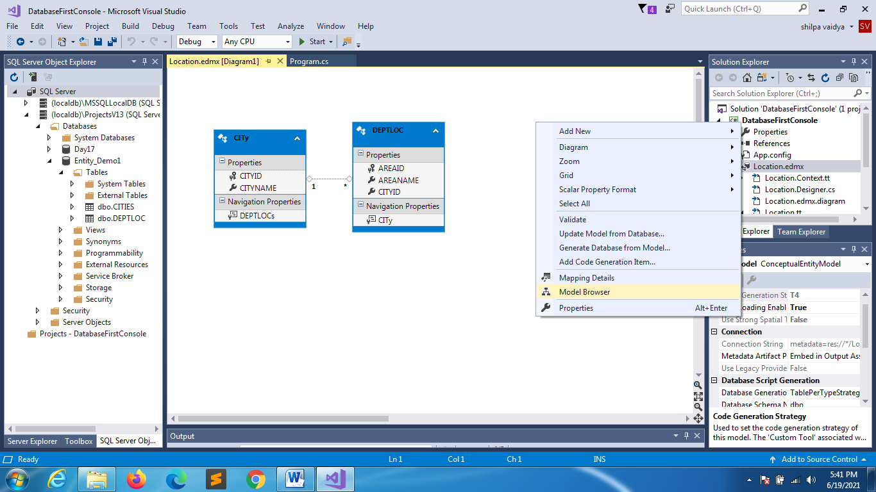

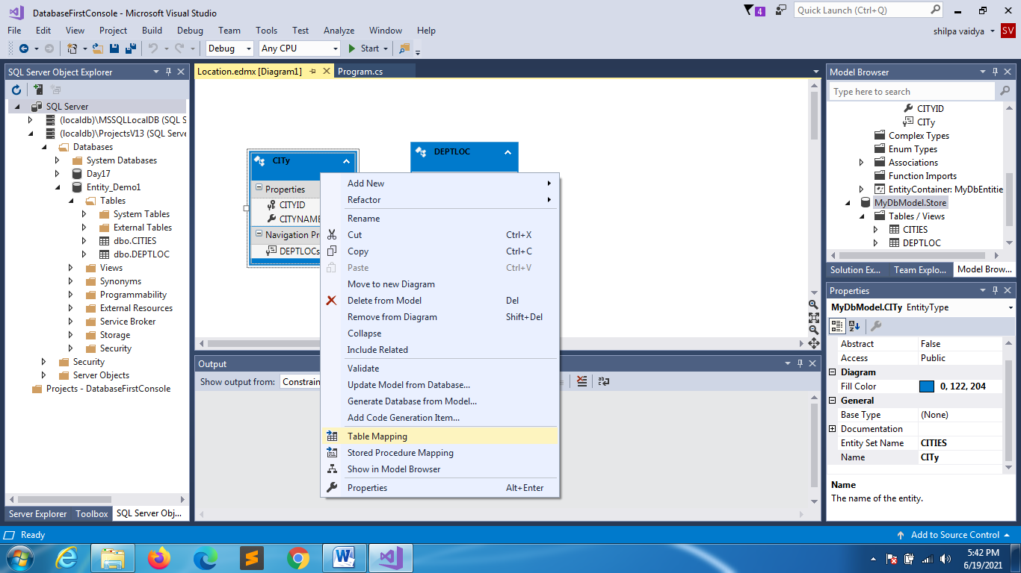

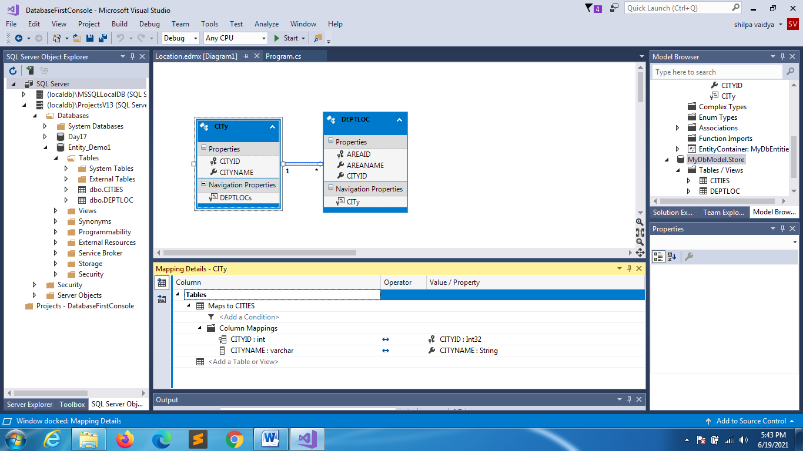

**Dbcontext**

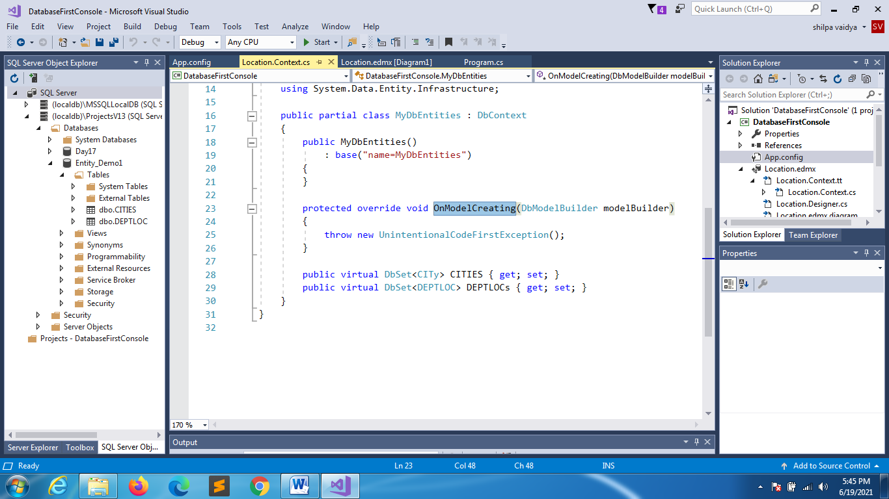

**City.cs**

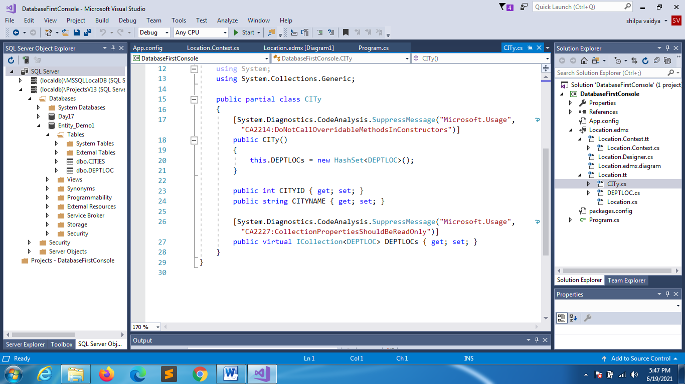

Must be public,virtual , icollection and the entity if it is area then property should be plural

Memories

allocated

**Deptloc.c**

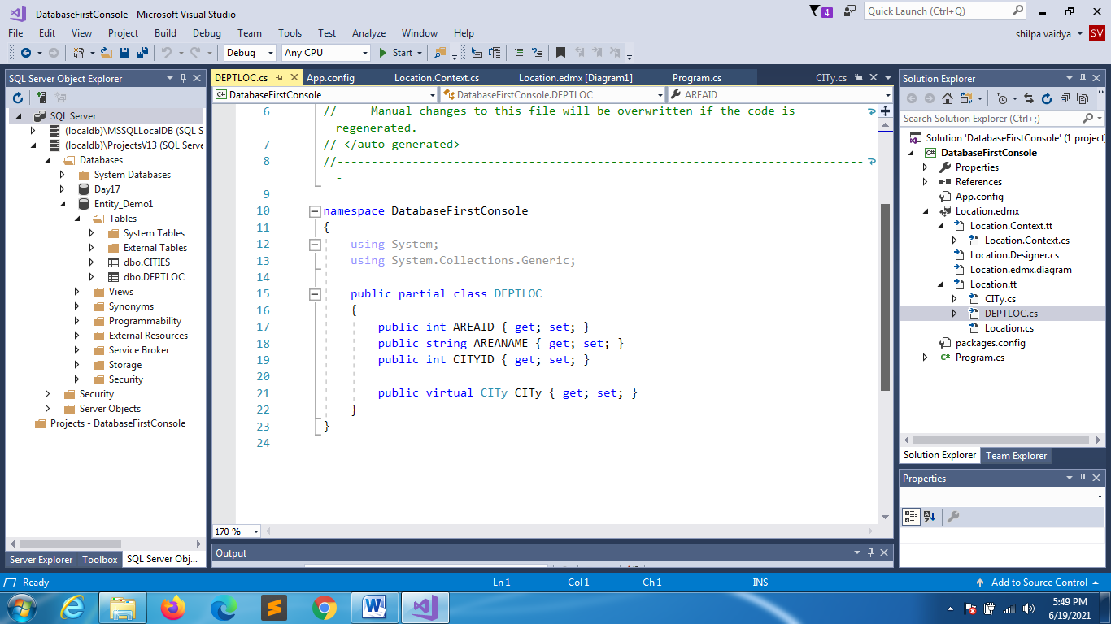

3 scalar properties

And 1 navigational property

**IF YOU UPDATE: DEPTLOC WITH ONE COLUMN**

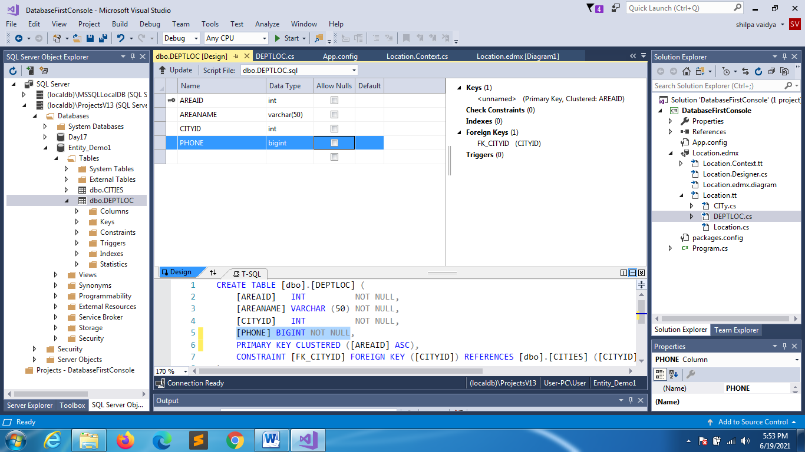

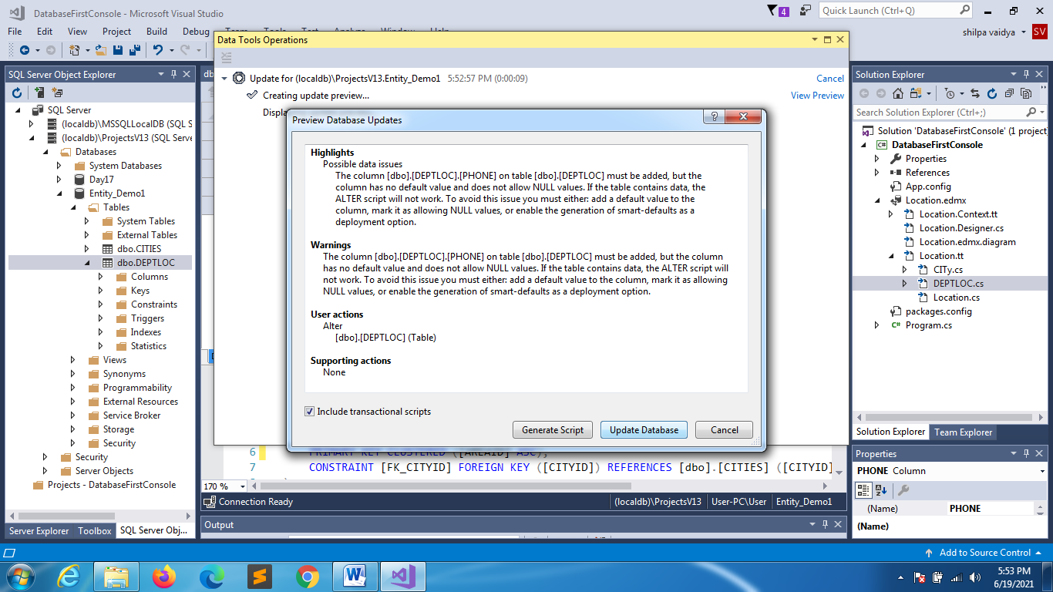

**TO REFLECT IT IN ENTITY DIAGRAM**

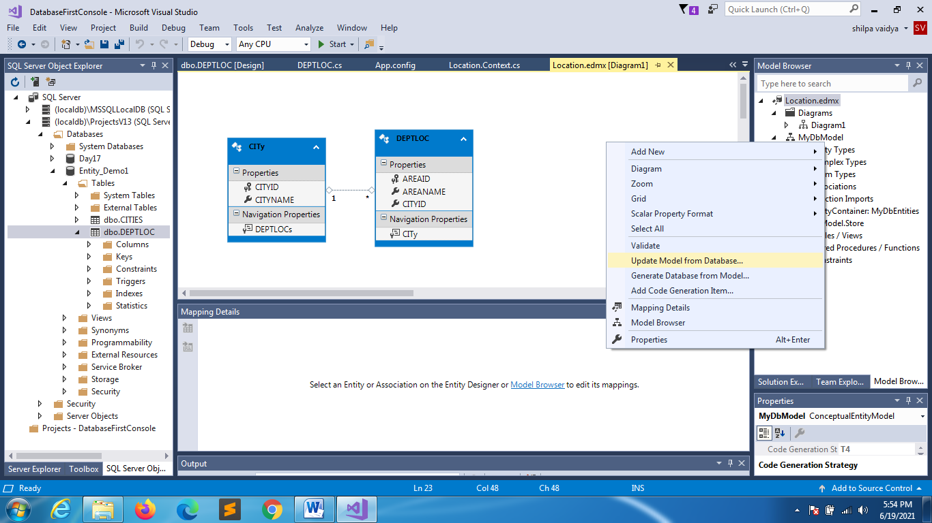

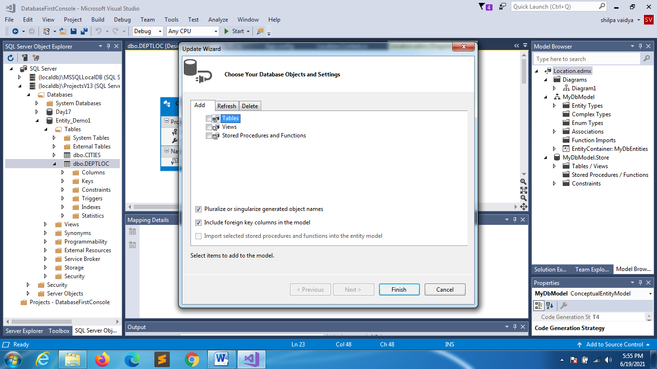

**YOU CAN SEE THE UPDATED RECORD**

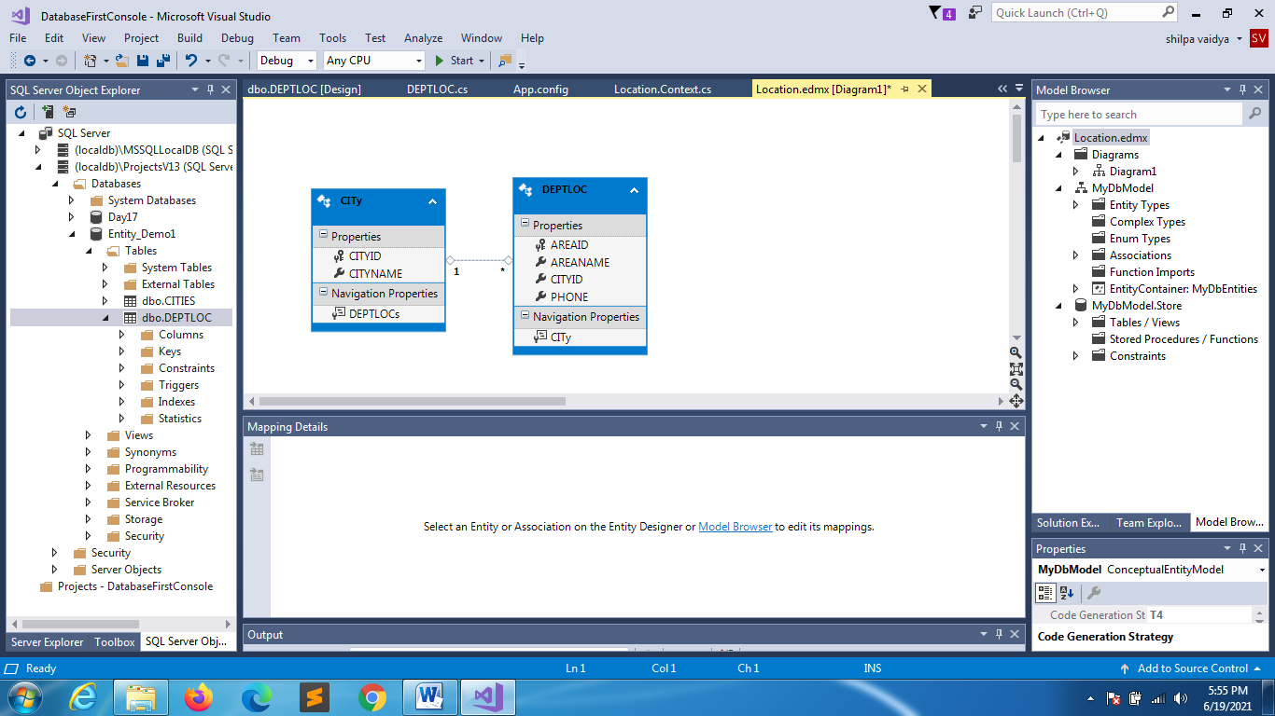

**SAVE ALL FILES**

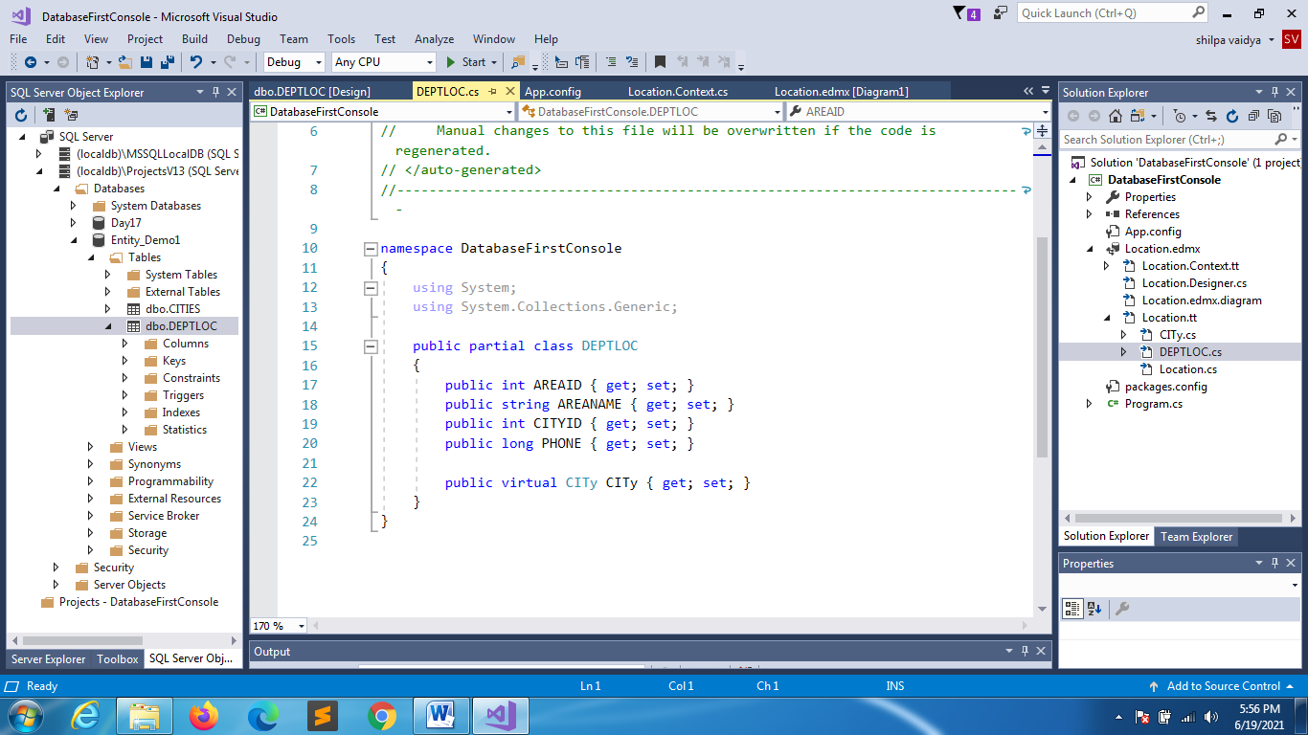

UPDATED